**Online Activity No. 8 and 9: Applying the User-Centered System Design Process**

**Objective**

1. Innovate an existing interactive system and computer technology.
2. Perform and apply UCSD.

**Materials**

* Personal computer
* Any software for (Computer aided designs) or programming language

**Background**

Atakan (2006), UCSD is used in the design process. Reasons are evaluated why traditional-technology-focused design processes may result in unusable systems-and the consequences of those unusable or useless systems. This leads directly to a consideration of the different methodologies that go to make up a user-centered system design process.

**Procedure**

1. Identify a scope or agenda
2. The format for the document is given below as a guide for the designers in the making the output both the document and design.

**Chapter I. Introduction**

**Background of the study**

The researcher’s application is DavGo, a navigation system designed to address the need of both newcomers and locals, providing directions to establishments integrating customer reviews and ratings. Additionally, it keeps users informed about local events and new establishment opening. The application by the researchers aims to fill the gap in current navigation with detailed, user-generated content and real-time updates, making city exploration more accessible and engaging.

The design of DavGo is highlighted by several key factors that make it unique to other applications. First, it doesn’t only provide directions but also in-depth information about the establishments, this helps users to make informed decisions. Second, newcomers to the city, such as students or tourists, often face challenges in finding reliable information about where to go, since existing applications do not address these needs, leaving users with outdated information. Locals can also benefit from the application to keep them updated about events and new openings, integrating real-time updates about local events and discounts, DavGo provides added features that go beyond simple navigation.

Therefore, DavGo was made to create a more user-centric and informative navigation system that improves city exploration experience. Addressing the limitations of current systems, the application aims to become an essential tool for navigating the city.

**Statement of the problem**

Compared to other navigation applications, there is a lack of integrated local information, as existing applications do not combine local reviews, ratings, and event updates, leading to users having difficulties when it comes to finding detailed and reliable information about establishments and events. Additionally, applications suffer from user engagement and personalization, lacking features such as personalized recommendations and user reviews and ratings, this would lead to not as much engagement and no tailored user experience. Finally, when it comes to letting the users be notified with local events, discounts, and new business openings, the researchers noticed that this would differentiate DavGo from other applications.

**Assumption of the study**

The DavGo application combines customer reviews and ratings, event updates, this is to help users' engagement and personalization ensuring the user to have access to detailed and reliable information about establishments and events. When it comes to real-time updates or information, DavGo provides timely notifications about local events, discounts, and newly opened establishments, enabling users to stay informed and take advantage of the opportunities. To overcome accessibility shortcomings, the application incorporates accessibility features to make it user-friendly for first time users.

**Significance of the study**

1. **City Tourists and Newcomers –** Tourists and newcomers to Davao will benefit the most from using the application as it provides navigation assistance, detailed local information, and event updates. This would help them explore the city, discover popular and hidden spots, and stay informed about local happenings.
2. **Local Residents –** Residents of Davao can use the application to explore new places within their city, find local events, and take advantage of discounts. The application’s personalized recommendations and detailed reviews would help them make informed decisions about where to go and what to do.
3. **Event Organizers and Local Business –** Benefit from the exposure provided by the application, by listing their events and promotions so that they can reach a wider audience.
4. **City Administrators and Planners –** Utilizes the data from the application to understand tourism trends, popular locations, and user preferences. This information can aid in urban planning, event organization, and enhance city services to cater to residents and visitors.
5. **College Students –** College students, especially those who are new to the city, will find the application helpful in navigating their surroundings, finding places to study or hang out, and staying updated on student-friendly events and discounts.
6. **Foodies and Hangout Seekers –** Individuals looking to explore new dining options and hangout spots will benefit from the detailed reviews, ratings, and personalized recommendations provided by the application, ensuring they have access to the best local experiences based on their preferences.
7. **Technology Enthusiasts –** Users interested in the latest technology will find the application’s features, such as real-time updates and interactive elements.

**Chapter II. Research Design**

This section discusses the design process model used by the group wherein it is composed of the following stages:

1. **Task Analysis**

Provide the hierarchical task analysis of the proposed design based on chosen scope both textual and figure.

1. **Navigate to a Location**

1.1. Open the DavGo app

1.2. Enter the desired destination in the search bar

1.3. Select the destination from the search results

1.4. View the route and directions

1.5. Follow the navigation instructions

2. **View Place Information**

2.1. Open the DavGo app

2.2. Search for a place or browse categories

2.3. Select a place from the list

2.4. View detailed information about the place

2.4.1. Read under reviews and ratings

2.4.2. View photos and descriptions

2.4.3. Check opening hours and contact information

3. **Leave a Review or Rating**

3.1. Open the DavGo app

3.2. Navigate to a place’s information page

3.3. Select the “Leave a Review” option

3.4. Enter a rating and write a review

3.5. Submit the review

4. **Discover Local Events and Discounts**

4.1. Open the DavGo app

4.2. Access the “Events” or “Discounts” section

4.3. Browse through the list of events or discounts

4.4. Save the event/discount.

1. **Requirements Gathering**

The researchers will focus on a mix of quantitative and qualitative methods through handing out a survey to 20 SHS and college students to participate in using the DavGo prototype. The participants will engage in tasks to determine if the prototype is a success, such as being able to use the navigation system and view the place’s information, being able to interact the place’s page such as leaving reviews or rating and be able to navigate or search the place’s location. The tasks outline the significant functions of the application, focusing on assessing the ease and accuracy of the navigation system and the accuracy of the place’s information, this is to make sure that the users understand the details of locations, evaluating the usability of user interactions with place-specific pages, and testing the application’s navigation accuracy.

The survey consists of a 5-Point Likert Scale and Feedback method, this will gather the participants’ experience and opinions.

|  |  |
| --- | --- |
| **Questions** | **Method of Answer** |
| Aesthetic Appeal | 5-Point Scale |
| Ease of Use |
| Design Consistency |
| Logo Representation |
| Overall Design Experience |
| Feature Usability | Feedback |
| Suggestions for Improvement |

Table 1. Survey Questionnaire

|  |  |  |  |
| --- | --- | --- | --- |
| **Scale** | **Range Value** | **Interpretation** | **Classification** |
| 5 | 4.50 - 5.00 | Highly Acceptable | Successful |
| 4 | 3.50 - 4.49 | Acceptable |
| 3 | 2.50 - 3.49 | Moderately Acceptable | Neutral |
| 2 | 1.50 - 2.49 | Fairly Acceptable | Unsuccessful |
| 1 | 1.00 - 1.49 | Not Acceptable |

Table 2. 5-Point Likert Scale Survey Interpretation

The table above presents the interpretation of the survey questions, giving insights on whether the system is efficient and successful in design and user experience.

The survey will be handed to the participants after the test via this link <https://forms.office.com/r/1yHH96xGhk>

**User Requirements**

* Accurate Navigation – Users need reliable and accurate navigation to various locations within the city
* Comprehensive Information – Detailed information about local spots, including reviews, ratings, photos, opening hours, and contact details
* Event and Discount Notifications – Requiring real-time updates on local events, discounts, and newly opened establishments
* Personalized Recommendations – Tailored to the user’s preferences and past activities
* Review and Rating Features – Users need the ability to leave, edit, and delete reviews and ratings for places

**Functional Requirements**

* + Search and Navigation – The system must provide search capabilities for locations and efficient navigation with turn-by-turn directions
  + Information Display – The application should display comprehensive information about each location, including user-generated content
  + Notification System – Send real-time notifications about events, discounts, and new establishments
  + Personalization Engine – The system recommends places based on user preferences and activity history
  + Review and Rating System – Allows users to submit, edit, and delete reviews and ratings

**Data Requirements**

* + Location Data – Accurate and up-to-date location data for navigation and information retrieval
  + User Data – Information about user preferences, reviews, and activity history to personalize recommendations
  + Event and Discount Data – Real-time data on local events, discounts, and new establishments
  + Review and Rating Data – User-generated content including reviews, ratings, and photos
  + Map Data – Detailed map for navigation

**Environmental Requirements**

* + Device Compatibility – The application should be compatible with a range of devices
  + Operating Systems – Support for Android 5.0 (Lollipop) and iOS 10 and above
  + Network Requirements – Efficient performance on both high-speed and slower internet connections
  + Battery Efficiency – The application should be optimized for low battery consumption

**Usability Requirements**

* + User-friendly Interface – The application must have an intuitive and easy-to-navigate interface
  + Consistency – Consistent design and behaviour across different sections of the application
  + Minimalist Design – Aesthetic and uncluttered design focusing on important features
  + User Control – Users should have control over their actions, with options to undo or redo actions easily

**Designers Requirements**

* + Design Tools – Utilizing Figma for creating and sharing prototypes
  + Collaborative Features – Tools for collaborative design work, allowing multiple members to contribute
  + Documentation – Comprehensive documentation of design decisions, user flows, and interface guidelines

1. **Storyboarding and Prototyping**

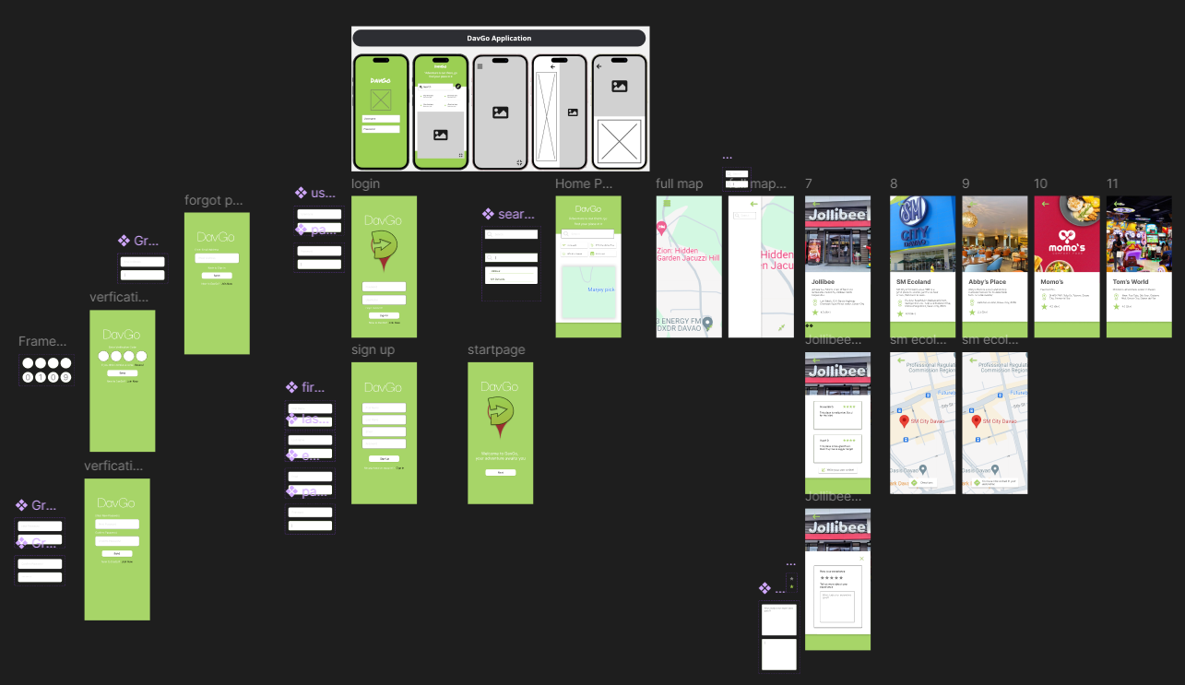

|  |  |
| --- | --- |
|  | 1. **This is where the DavGo logo will be displayed** 2. **The user needs to input their username and password to enter the app** 3. **This is where users search for their desired location** 4. **Events or sales of places** 5. **Minimized version of the map**   The CRUD (Create, Read, Update, Delete) feature applies here by letting the user create account and add places, reviews, and/or events, businesses can even create posts to promote their business or events, users would be able to view, update, or delete their own reviews. |
|  | **Full display of the map**  This would appear if the user pressed the full screen button on the minimized map. |
|  | 1. Where details of the place would be displayed, alongside a search bar so the users would be able to still search for a new place. 2. Displays information about the place with a picture above. |

A storyboard or flow of the entire picture of the interactive system will be shown here.

The prototype of the interactive system -System input and output forms should be presented here and will be described on how it will function when the user utilizes it **(this part will be presented as a user’s manual including the description and functions of the parts of the hardware/technology)**

1. **Evaluation of prototype**

Evaluation Criteria (Based on the 10 heuristics of design evaluation)

|  |  |  |  |  |  |
| --- | --- | --- | --- | --- | --- |
| **Area of Evaluation** | **5** | **4** | **3** | **2** | **1** |
| 1. **Visibility of System Status**  * - The system design provides appropriate feedback like message prompts in response to user actions. * The message prompts are clear, visible and understandable. |  | / |  |  |  |
|  | / |  |  |  |
| 1. **Match between the system and the real world**   - Used words, phrases and concepts according to users’ language rather than system-oriented words and computer jargons. | / |  |  |  |  |
| 1. **User control and freedom**   - The system design provides ways of allowing users to easily “get in” and “get out” if they find themselves in unfamiliar parts of the system. | / |  |  |  |  |
| 1. **Consistency and Standards**  * - The colors, text, labels, buttons and other elements in the design are uniform from start to finish**.**   - Text and icons are not too small or too big.  **-** Menus and other features of the system are arranged and positioned in a consistent way. (For ex. If your website has navigation buttons on the top under the page title on one page, the users will automatically look there for the same features on other pages. | / |  |  |  |  |
| / |  |  |  |  |
| / |  |  |  |  |
| 1. **Error Prevention**   - The system design provides automatic detection of errors and preventing them from occurring in the first place.  - Idiot proofing mechanisms are applied |  |  | / |  |  |
|  | / |  |  |  |
| **F. Help users recognize, diagnose and recover from errors**  **-** Error messages and the terms used are recognizable, familiar and understandable for the users. |  | / |  |  |  |
| **G. Recognition rather than recall**  **-** Objects, icons, actions and options are visible for the user.  - Objects are labeled well with text and icons that can immediately be spotted by the user and matched with what they want to do. | / |  |  |  |  |
| **H. Flexibility and efficiency of use**  - The system design provides easy to navigate menus.  - the system does not make wasteful time of system resources. | / |  |  |  |  |
| 1. **Aesthetic and minimalist design**   **-**Graphics and animations used are not difficult to look at and does not clutter (mess) up the screen.  - Information provided is relevant and needed for the system design. |  | / |  |  |  |
| 1. **Help and Documentation**   **-**the system design provides information that can be easily searched and provides help in a set of concrete steps that can easily be followed. | / |  |  |  |  |

**Chapter III. Conclusion and Recommendation**

DavGo, a navigation application designed to address the shortcomings of existing solutions, was presented in this study. DavGo integrates customer reviews, ratings, and event updates, aiming to enhance user experience by providing detailed and reliable local information. Features like personalized recommendations and user-generated content foster user engagement.

This project provided valuable insights into Human-Computer Interaction (HCI) principles. Focusing on user needs throughout the design process resulted in a navigation application that caters to a diverse range of users. The successful integration of various data sources enhances the user experience. Encouraging user participation through reviews, ratings, and personalized recommendations fosters a more engaging and dynamic application.

DavGo's future development should prioritize map-based features to further enrich the user experience. Heatmaps can visually represent areas teeming with popular establishments or events, helping users discover hidden gems and trending spots. Personalized routing can consider user preferences like budget or family-friendliness when suggesting the most suitable paths. Additionally, curating map collections based on user interests (foodie destinations, nightlife, historical landmarks) can streamline trip planning and exploration. By continuously integrating these map-based features and user feedback, DavGo can become an indispensable tool for navigating Davao City and unlocking its vibrant offerings.